Date: January 17, 2024
To: Weber County Board of County Commissioners
From: Ronna Tidwell
Community Development Department
Agenda Date: January 23, 2024
Subject: Request for approval to sell surplus property identified as Parcel 05-136-0039
Attachments: A - Aerial Vicinity Map
B - Ownership Plat
C – Real Estate Purchase and Sale Agreement
D – Quit Claim Deed

_____________________________________________________________________________________

Summary:
A Weber County owned parcel of land, identified as Tax ID #05-136-0039, was acquired by the County through a tax sale process and deed executed in June of 1981. The parcel contains approximately .01 acres and is located at the rear of 16 E Chimes View Circle, South Ogden. See Attachment A for a vicinity map and Attachment B for the County Recorder’s ownership plat map.
The County has been contacted by an adjacent property owner who has asked if the County would consider selling the subject parcel.
Weber County has no intended use for this property; therefore, it is recommended that the parcel be sold to the adjacent property owner for $2,000.00. The fair market value was determined by the Weber County Assessor’s office, consistent with Sec. 2-21-2(d)(1), or the county’s surplus property code.

Property Description:

05-136-0039

PART OF THE SOUTHEAST QUARTER OF SECTION 5, TOWNSHIP 5 NORTH, RANGE 1 WEST, SALT LAKE MERIDIAN, U.S. SURVEY: BEGINNING AT A POINT WHICH IS 22 CHAINS WEST AND 16.80 CHAINS SOUTH 38D WEST AND 165 FEET SOUTH 52D EAST AND SOUTH 12D 15' WEST 492 FEET, MORE OR LESS TO A POINT WHICH IS WEST OF THE SOUTHWESTCORNER OF THE PROPERTY CONVEYED TO EDWARD A RICHE AND WIFE, BY DEED RECORDED IN BOOK 925 OF RECORDS, PAGE 80; FROM THE NORTHEAST CORNER OF SAID QUARTER SECTION, RUNNING THENCE EAST TO THE SOUTHWEST CORNER OF THE PROPERTY SO CONVEYED; THENCE NORTH 13D EAST 28.47 FEET; THENCE NORTHWESTERLY TO A POINT NORTH 12D 15' EAST FROM THE POINT OF BEGINNING, THENCE SOUTH 12D 15' WEST TO THE POINT OF BEGINNING.
Attachment A

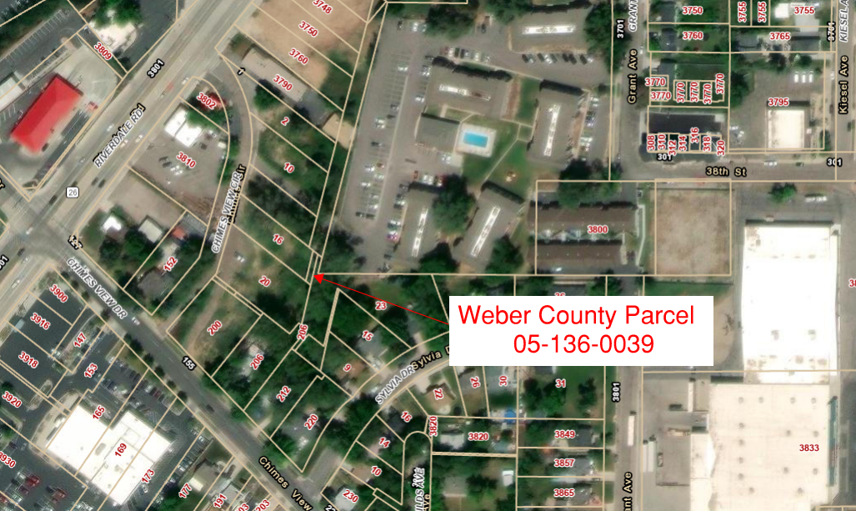

Attachment B
